Task 8 — Step 1: Check Tomcat before configuring deployment
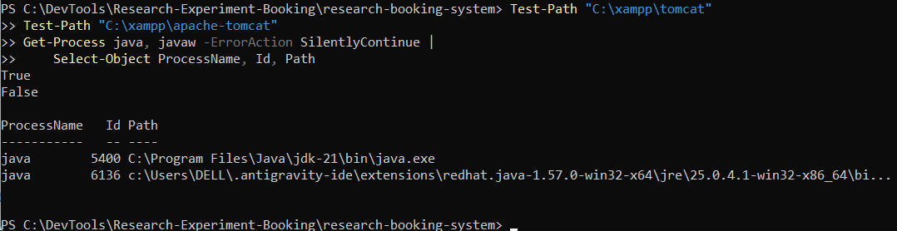
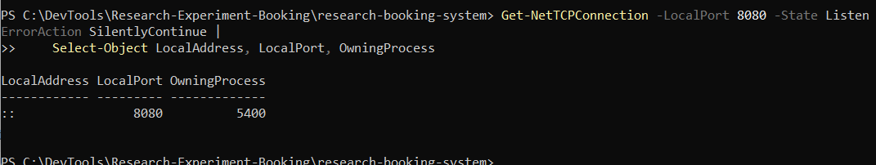
Task 8 — Step 2: Identify the server
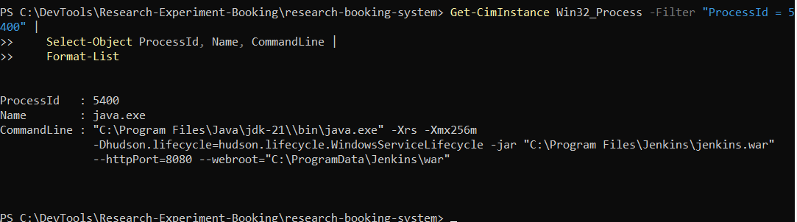
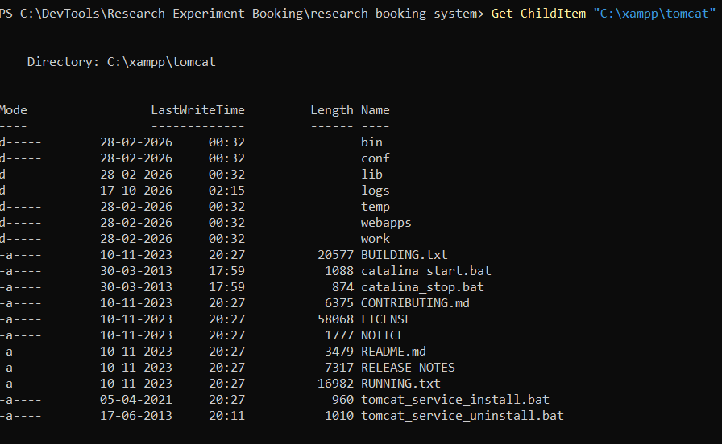
Task 8 — Step 3: Check Tomcat configuration
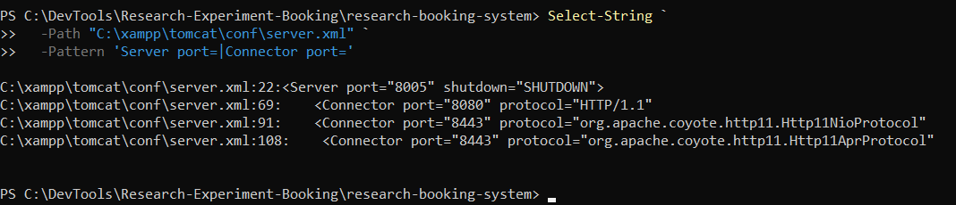
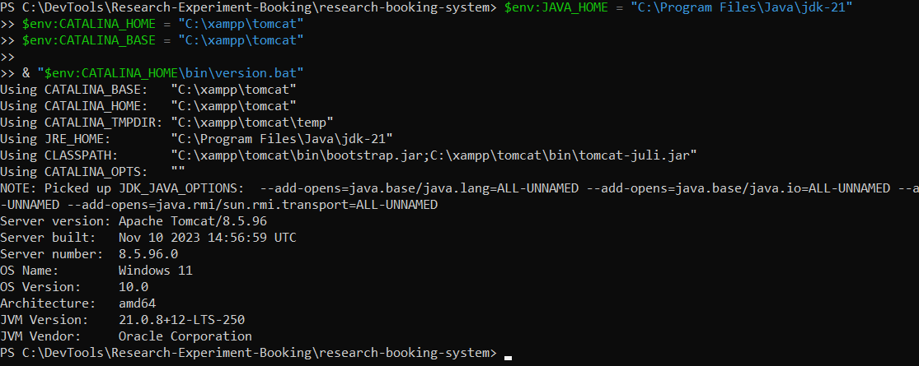
Task 8 — Step 4: Check the remaining configuration
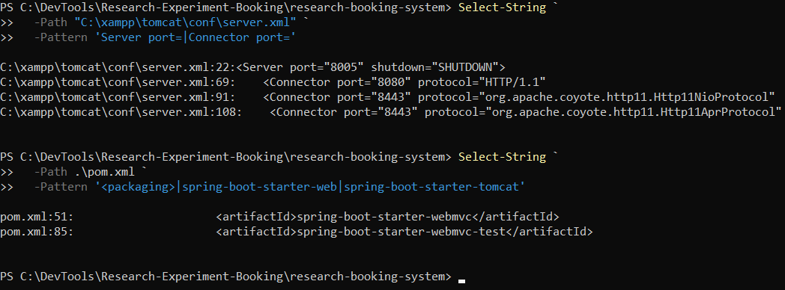

Nginx reverse proxy + Spring Boot on port 8081
Step 1 — Verify the project and application port
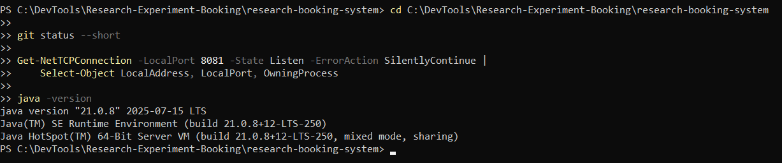
Step 2 -- Check Maven and the project files
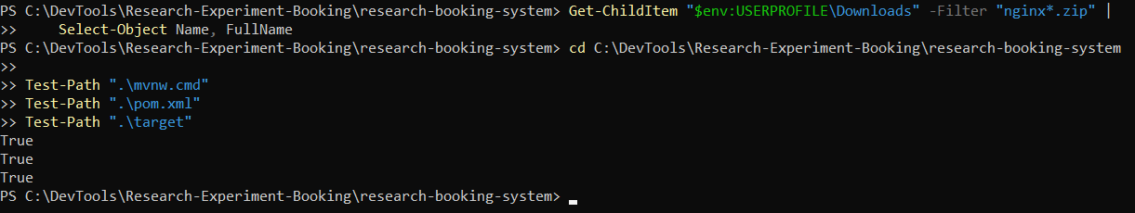
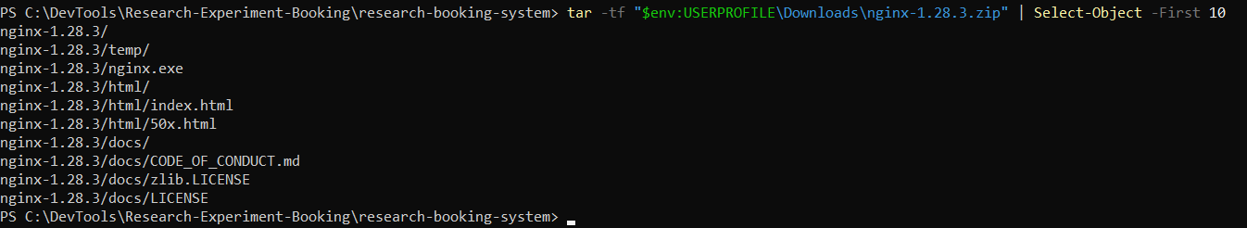
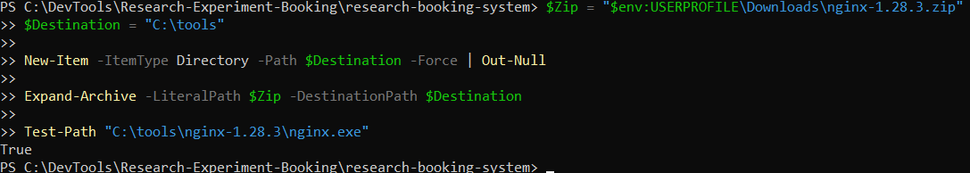
Step 2 — Verify Nginx and its configuration
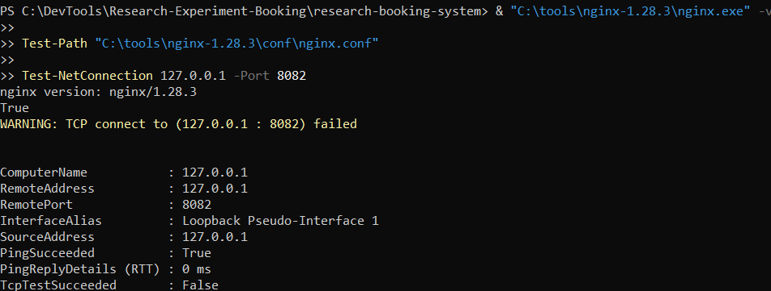
Step 3 — Configure Nginx as a reverse proxy
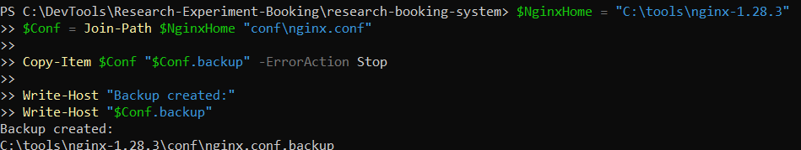
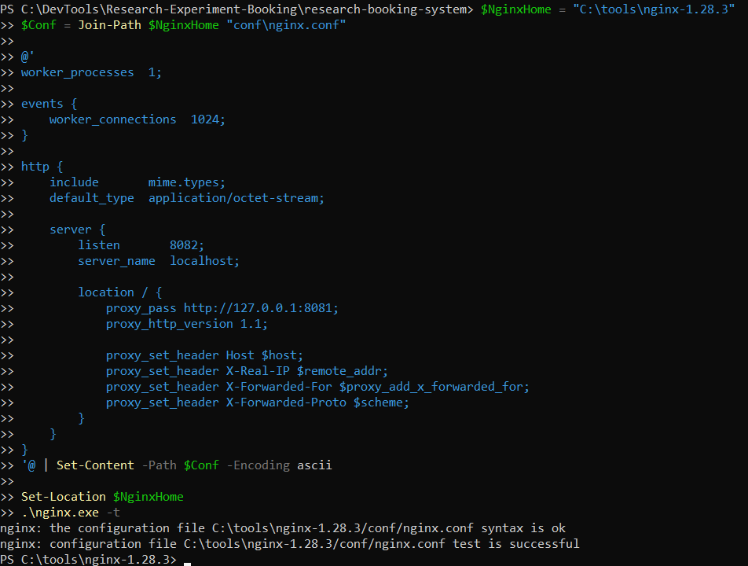
Step 2 — Build and test your Java project
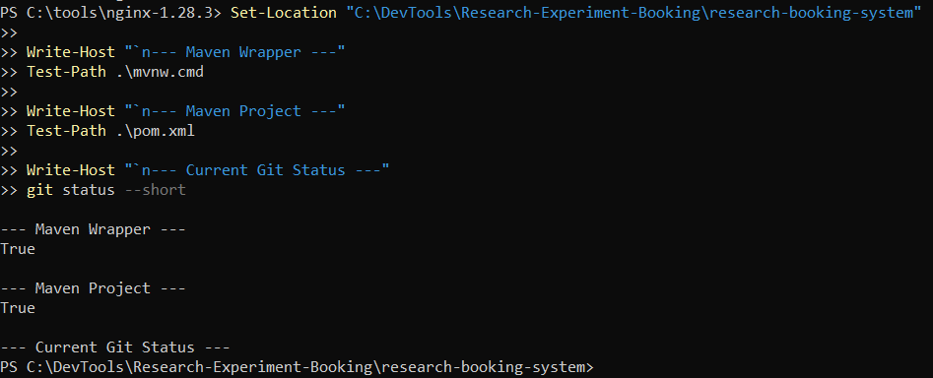
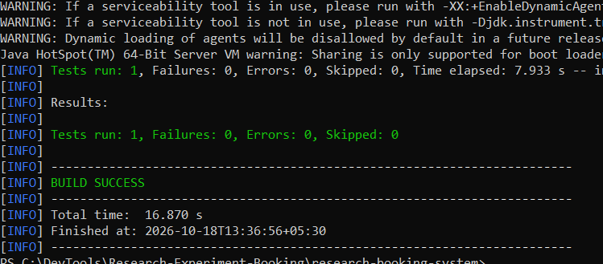
Step 4 — Package the application
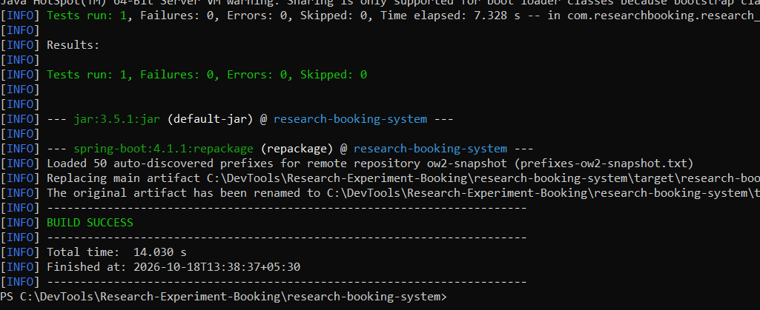
Step 5 — Start the Spring Boot application
Step 6 — Verify Spring Boot
Test-NetConnection 127.0.0.1 -Port 8081
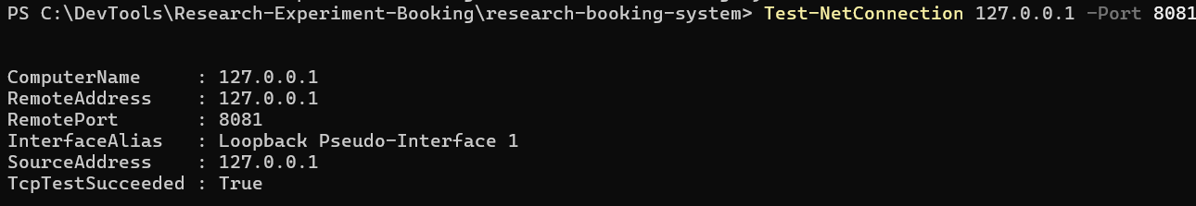
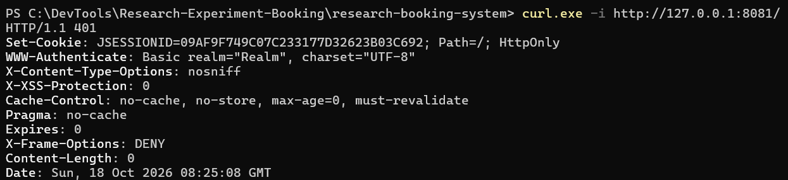
Step 7 — Start Nginx

Inspect your Spring Security setup
Create the Jenkinsfile
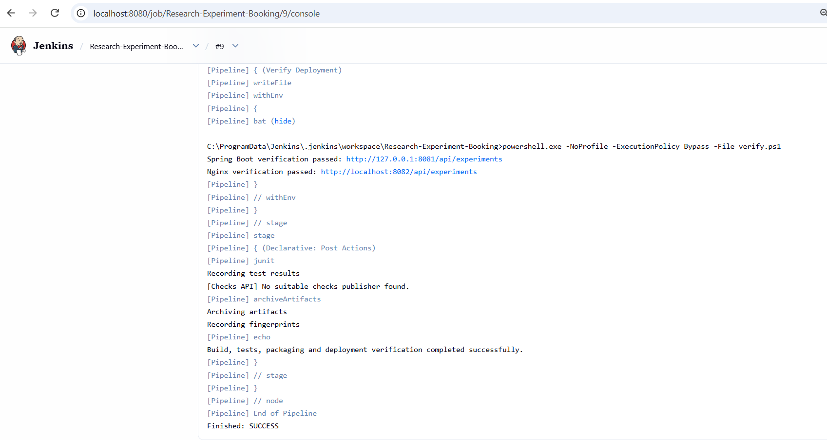
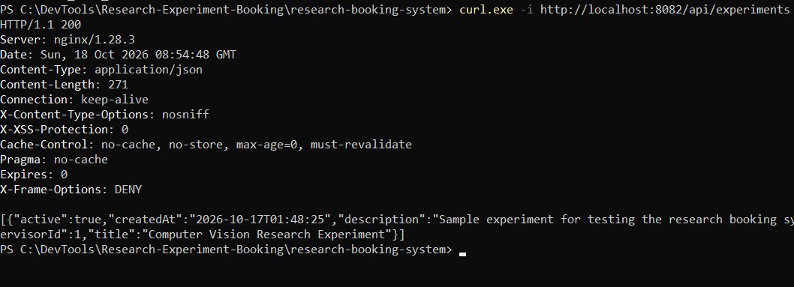
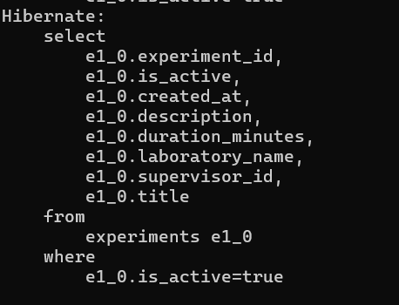
Persistent
